CS551 Advanced Software Engineering

Midterm: Hackathon (Take-home programming)

REPORT

BY

NAME: SRUJANA KONDAMADUGULA

STUDENT ID: 16157492

EMAIL ID: skkd2@mail.umkc.edu

REPORT

1.Design

1. Architecture Diagram of the System

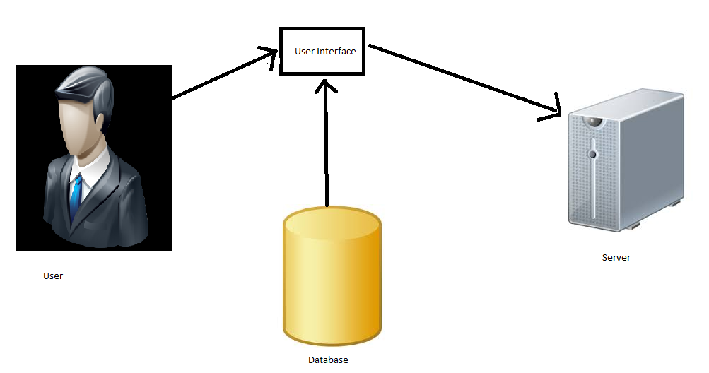

1. Class Diagram

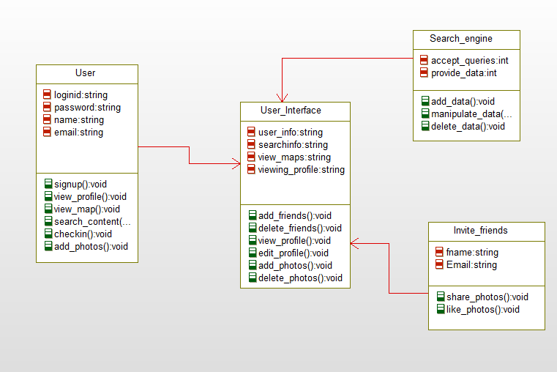

2) Report

--I have developed a Mobile Web application based on the given requirements. The screen shot of my mobile web application is shown below. The primary purpose of this application is to create travel application for creating routes, adding photos, viewing recent visit history etc.

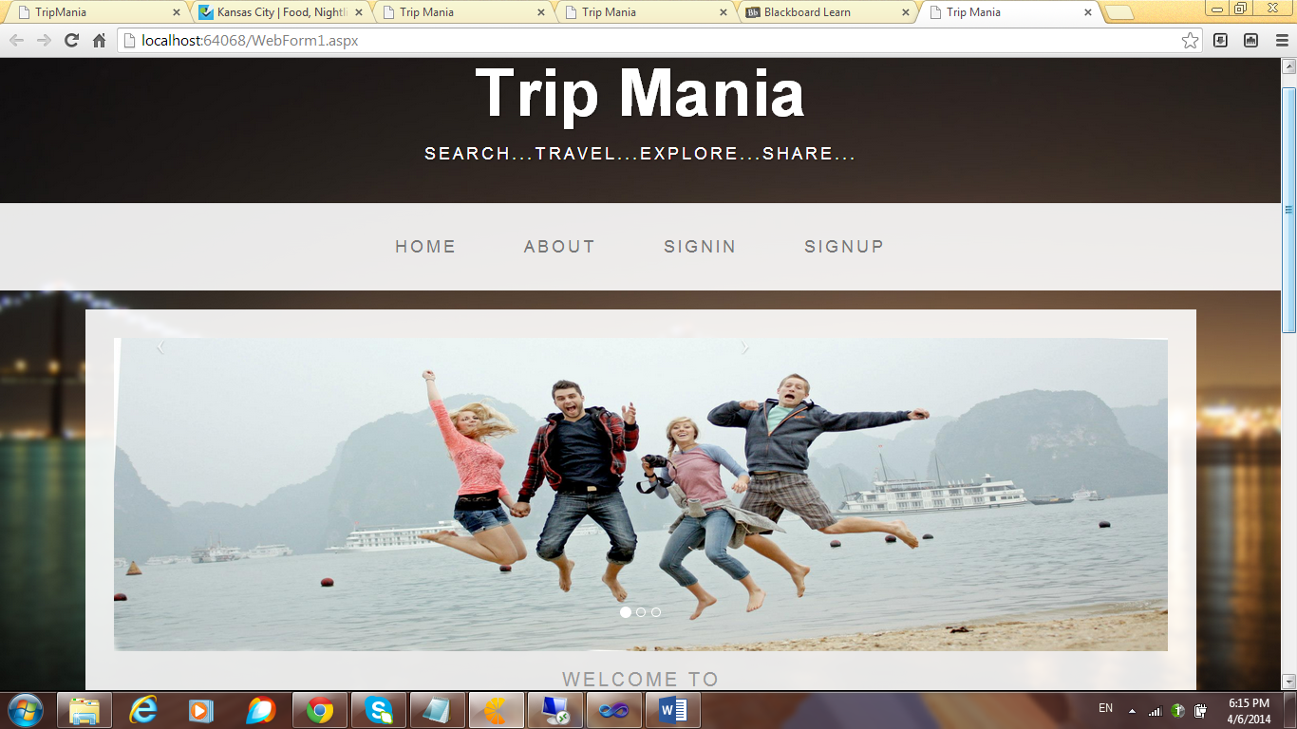

--I have developed the application in asp.net and I have made use of Twitter bootstrap so that it would be compatible with any kind of device. When the web application is deployed on to a mobile device, the screen shot of the mobile application is as follows.

--The application looks like this in a mobile, it goes well with OS and android as well, this is the main advantage of using twitter bootstarp.

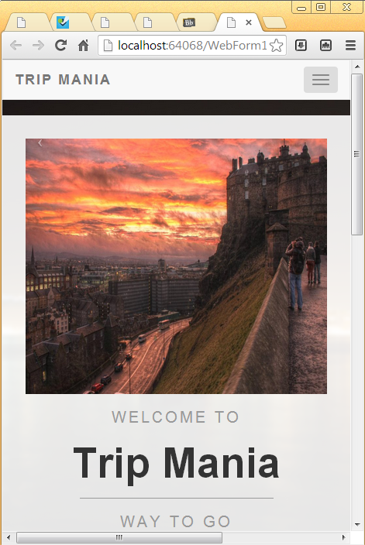

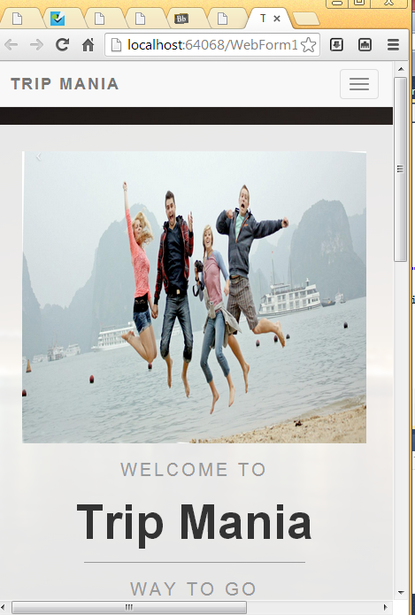

--When the icon on the top right corner is clicked, the home, about, sign in and sign up links appear as shown below.

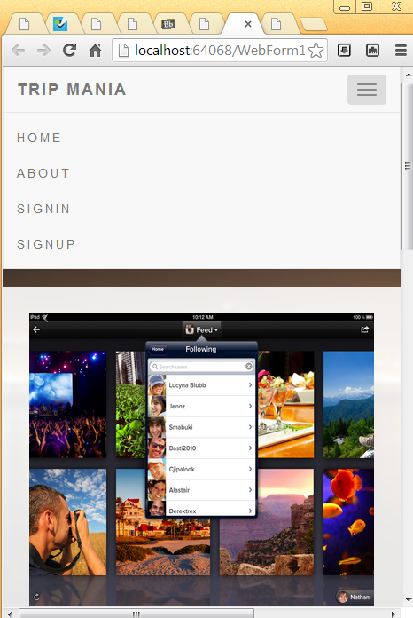

--In the main page, as we can see there are four page navigations and they are home, about, sign in and signup. I have used three images and they slide from one to other in timely fashion, I have shown the slide show of images in the application in the figures below.

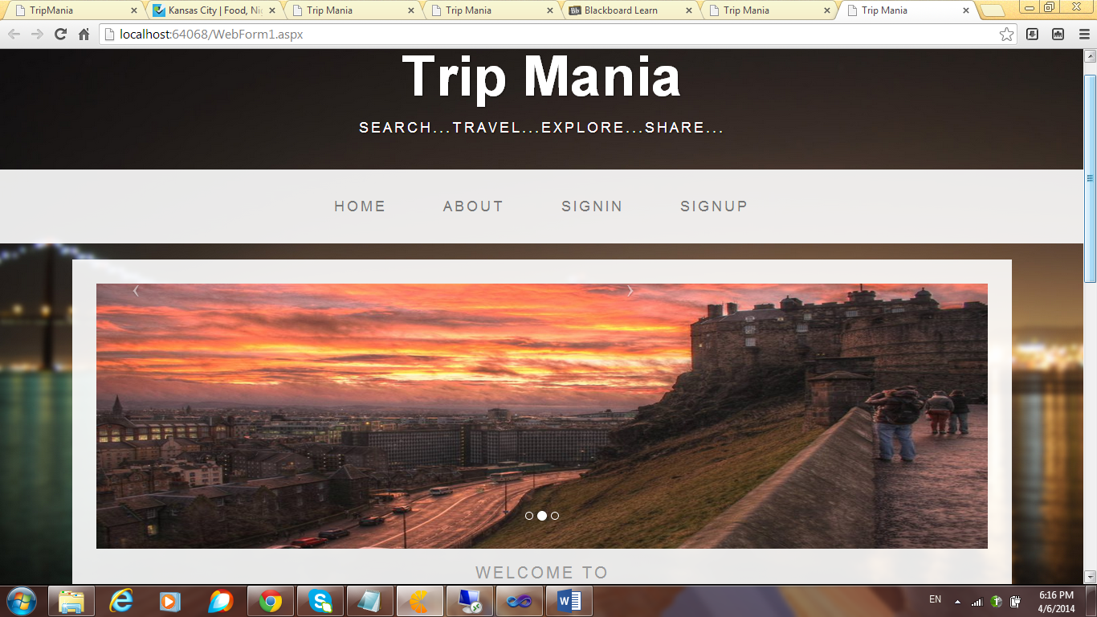

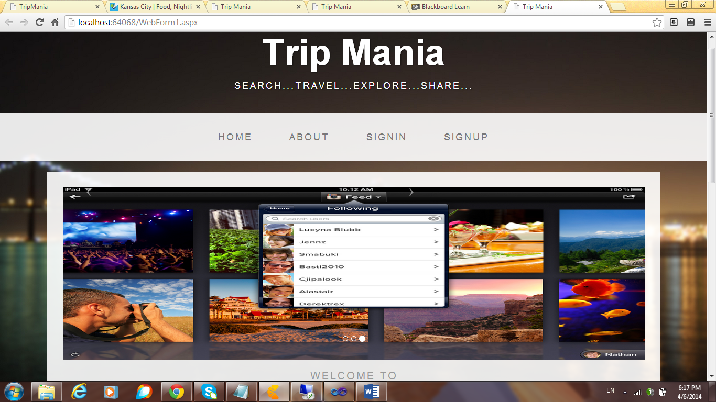

--The major purpose of using this is to make the mobile web application very attractive and responsive.

When the application is scrolled down, a welcome contents as shown in the figure appears.

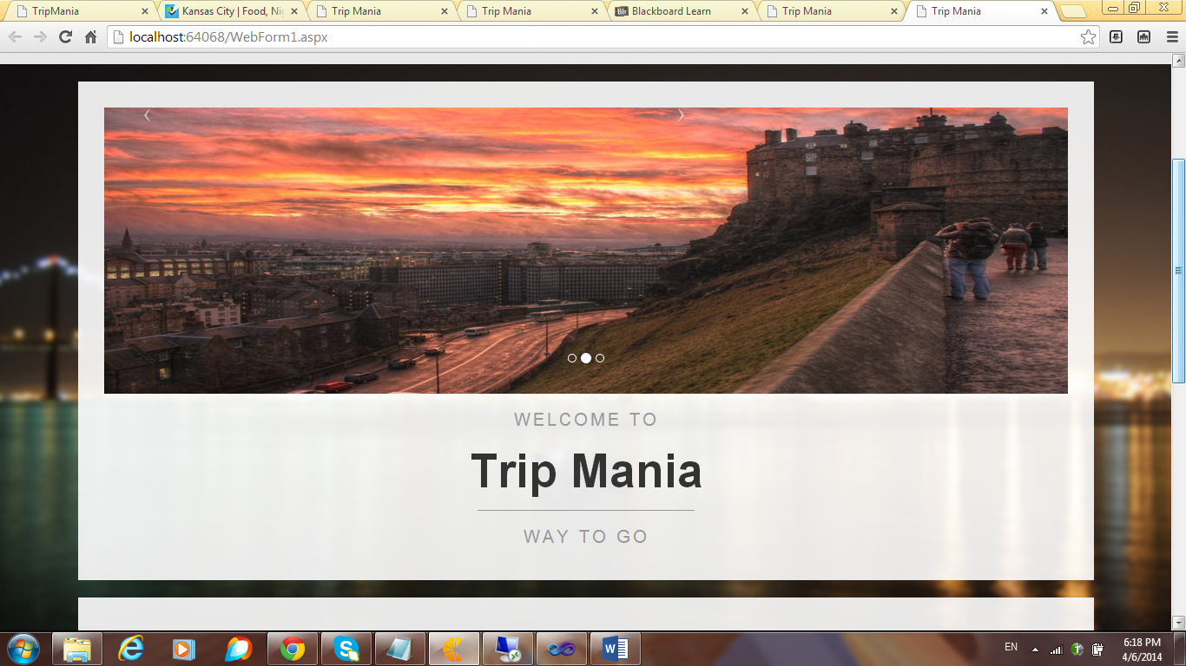

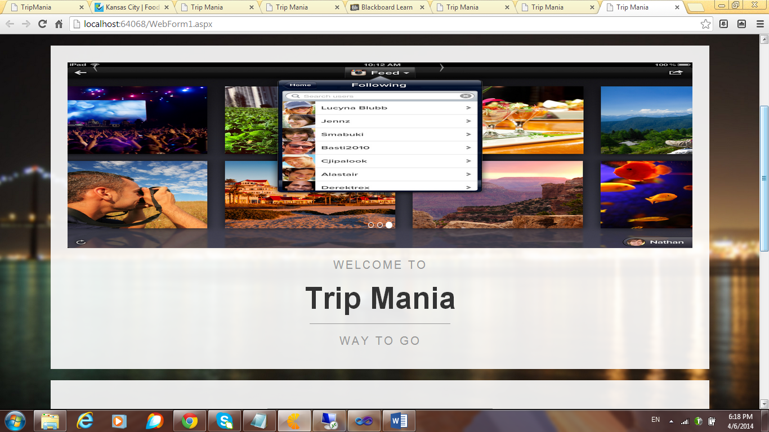

--When the application is further scrolled down, the following appears, I have added “quote of the day” to make it more attractive, users are attracted to any application if its UI looks good and attractive.

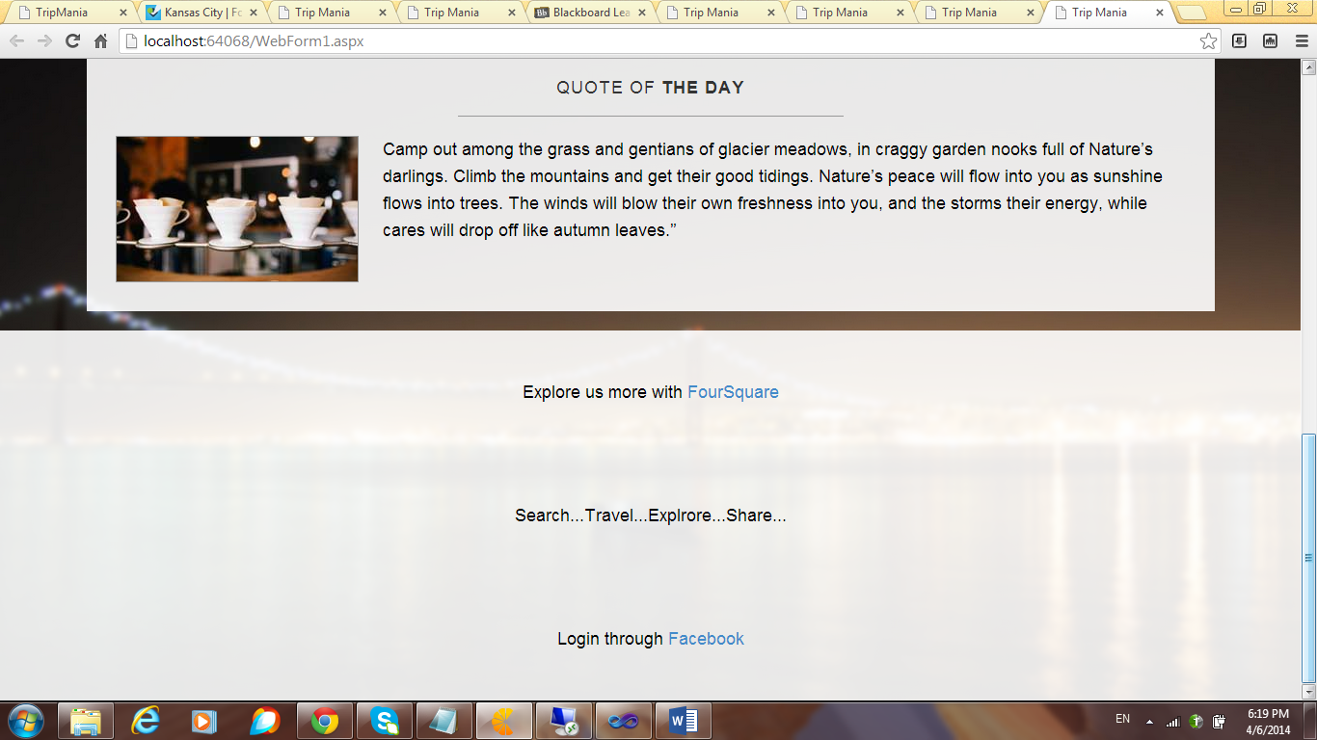

--I have provided links at the bottom of the page, the links are Four Square and Facebook, four square is a useful application that is very similar to the application, it basically aims at making trips easier. When the four square link is clicked, the following four square main site appears, the user can very conveniently browse through to get the necessary data.

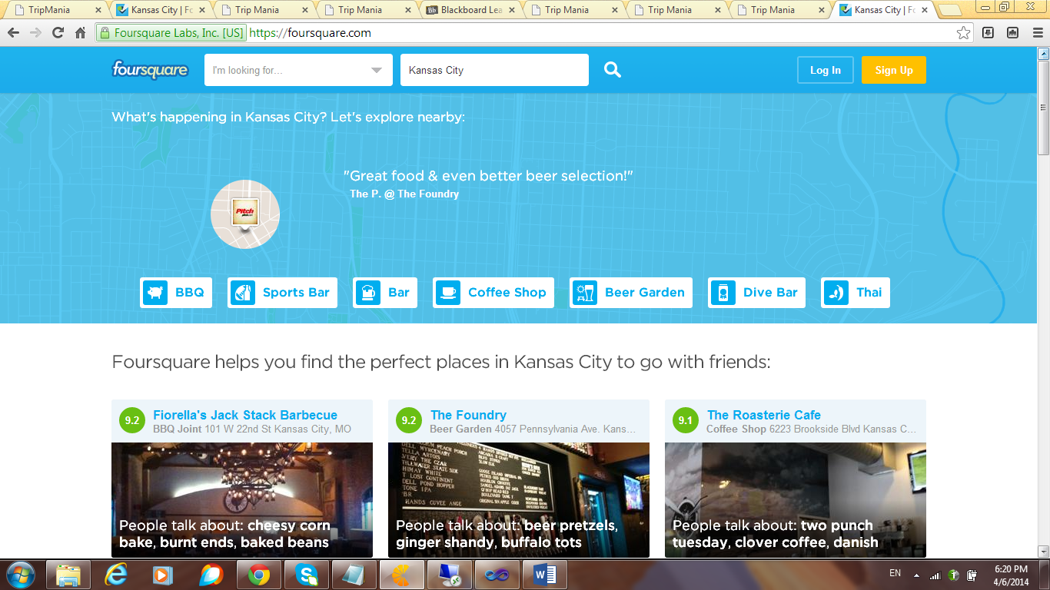

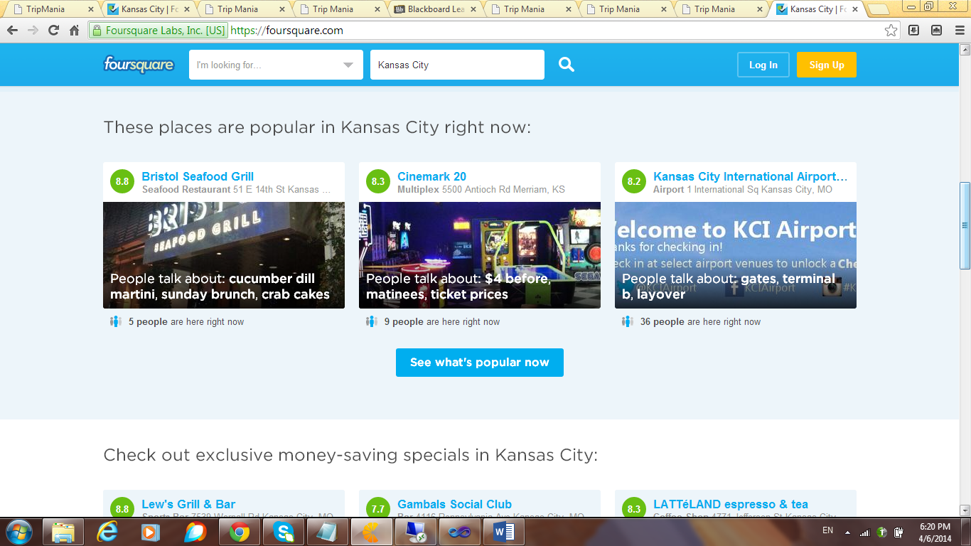

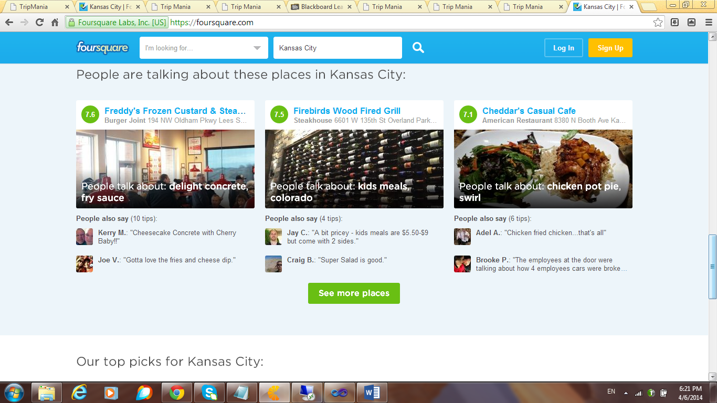

--When the user clicks the facebook link, he is directed to the the following Facebook main page, and he can share the pictures or checkin at a place and there by notifying the friends.

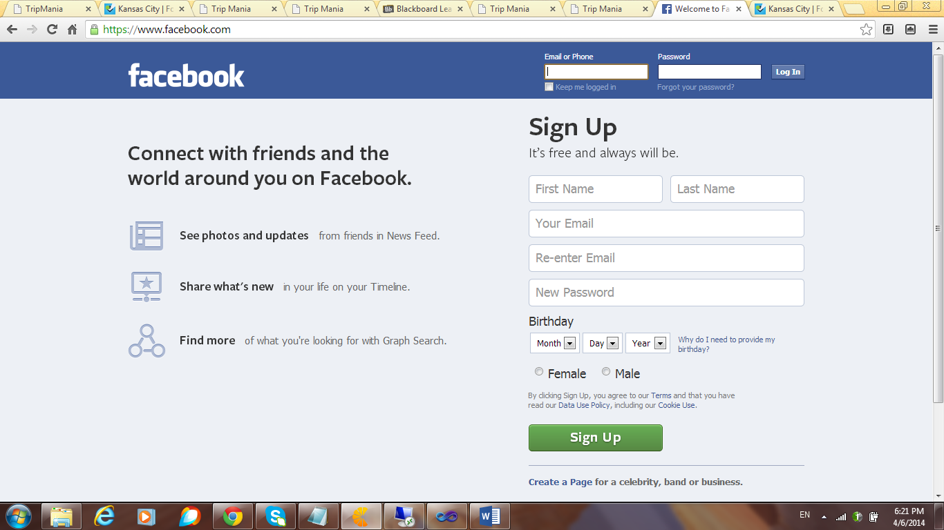

--The user can conveniently check in as shown in the figure below.

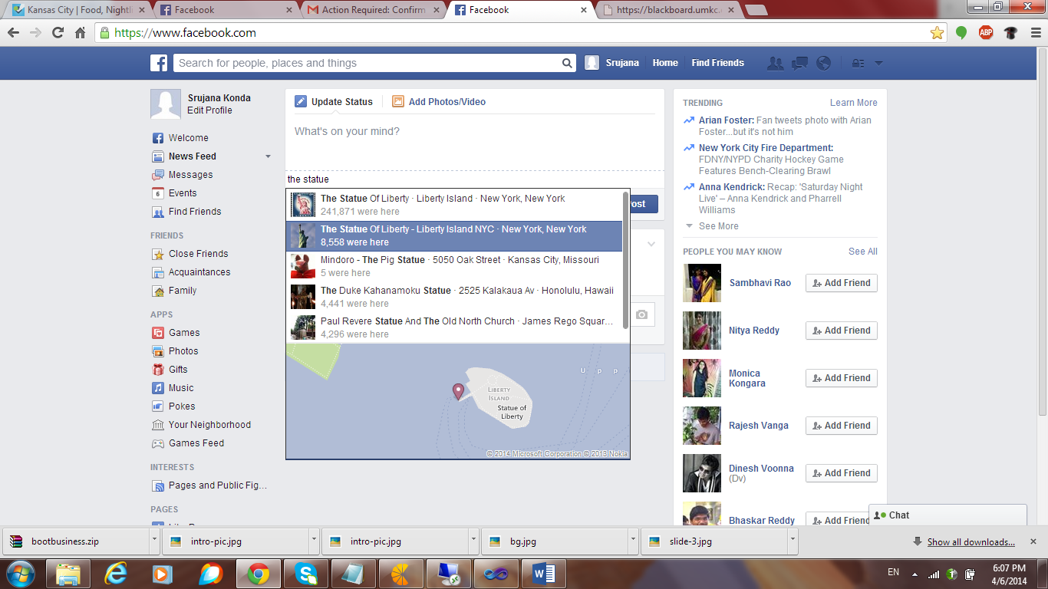

--The information goes is updated to his friends.

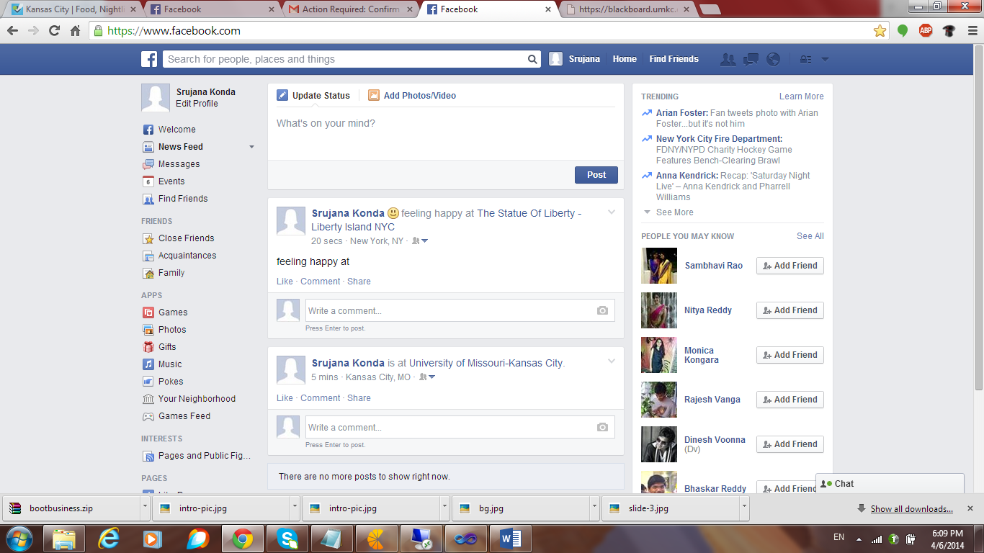

--The user can add/share photos through the Facebook login.

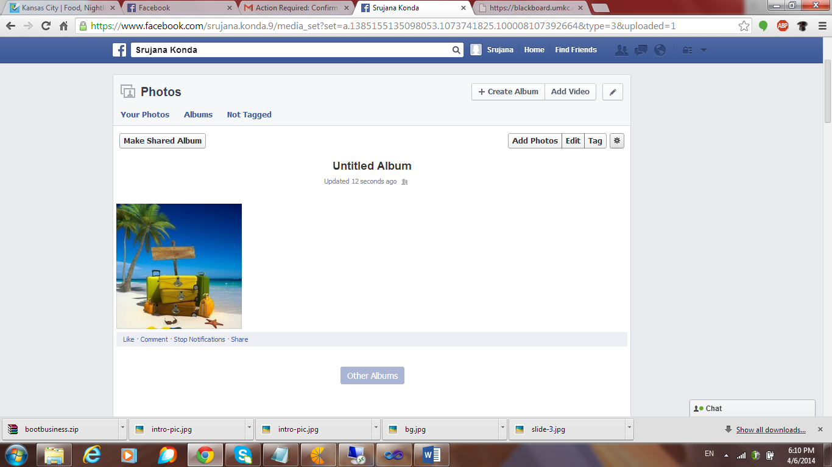

--As told earlier, the home page has four buttons, the first being the home page, when the “about” is clicked, the following page appears. I have included the information relating to the application in the about page. The screen shot of this is as follows,

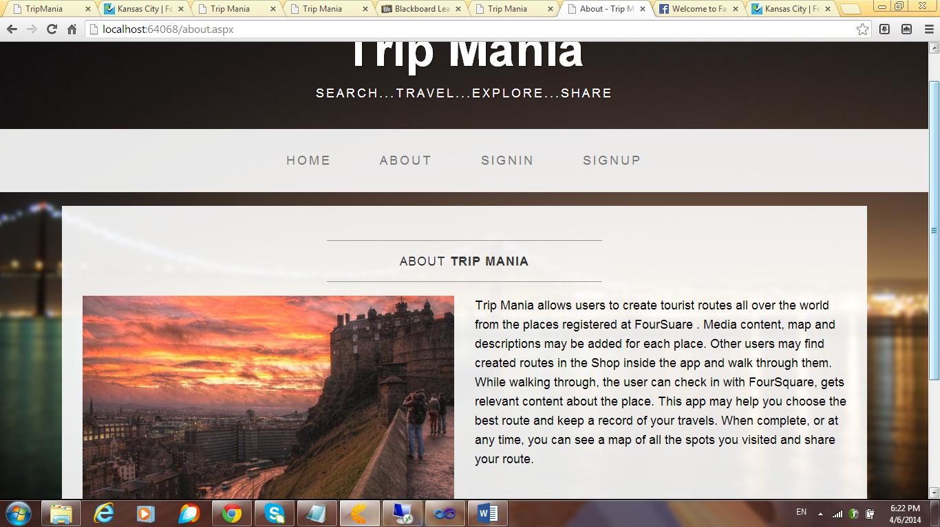

--When the Sign In link is clicked, the following page appears, the user can sign in here by providing his credentials.

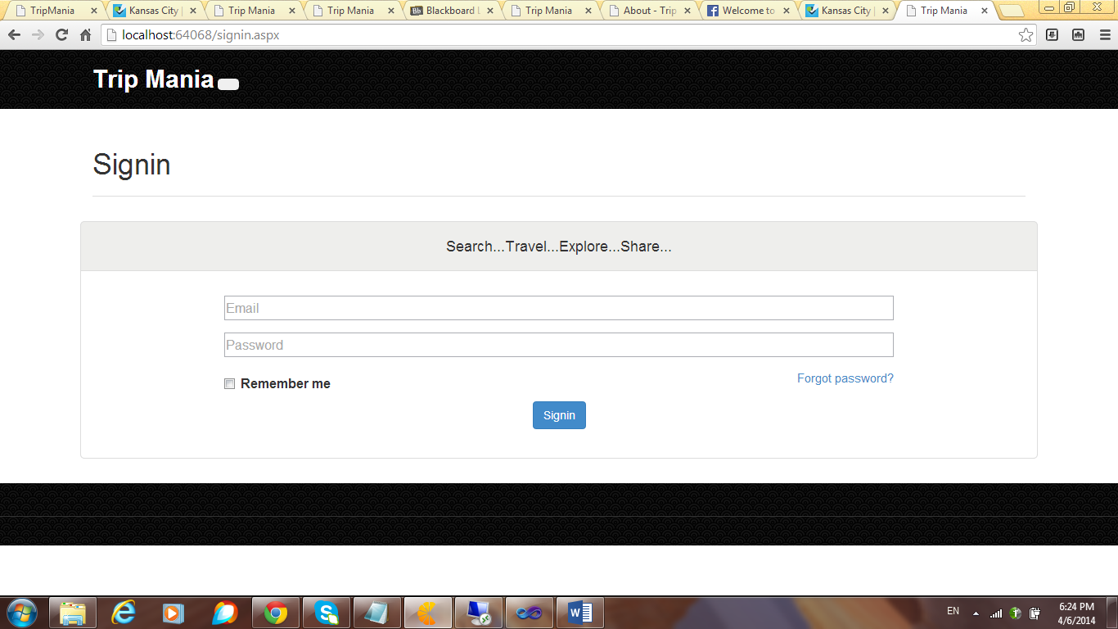

--If the user is new to the application, he has to register by clicking on the signup link. The sign up link looks as shown in the figure.

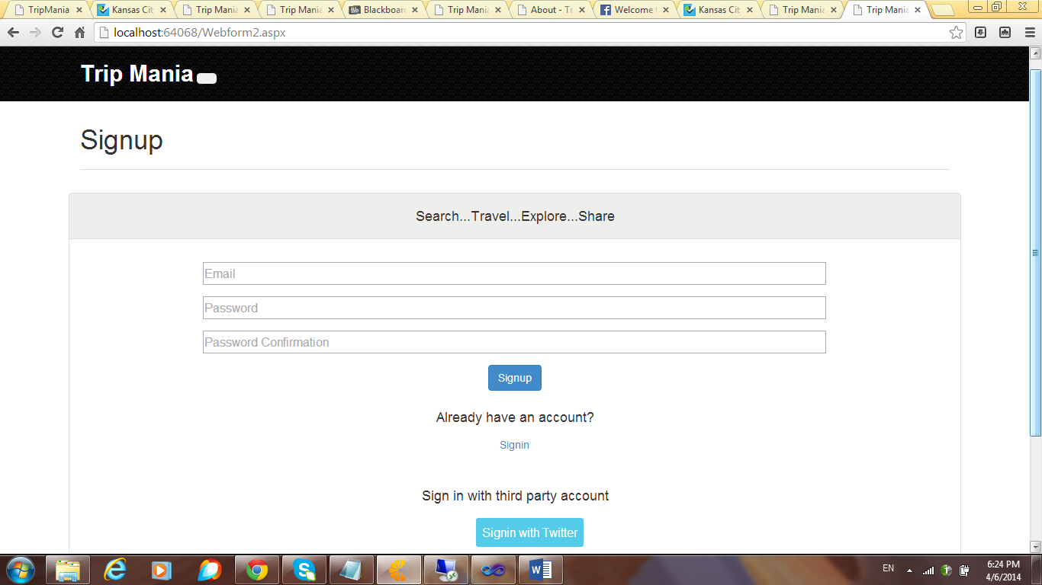

--The user signs up by providing his details.

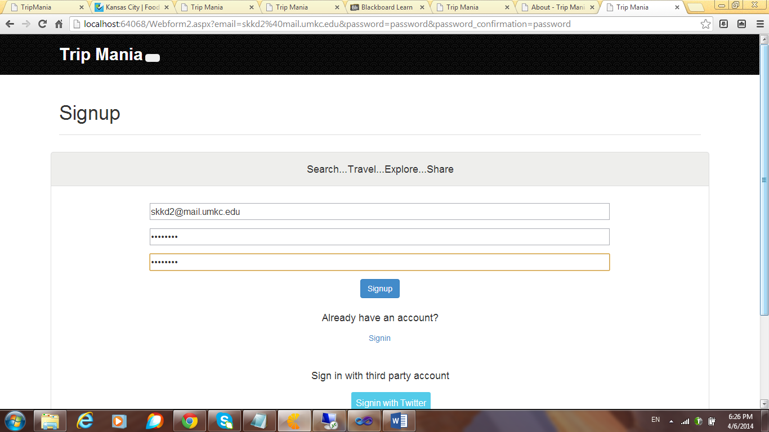

--The user can sign in to the application by providing the credentials.

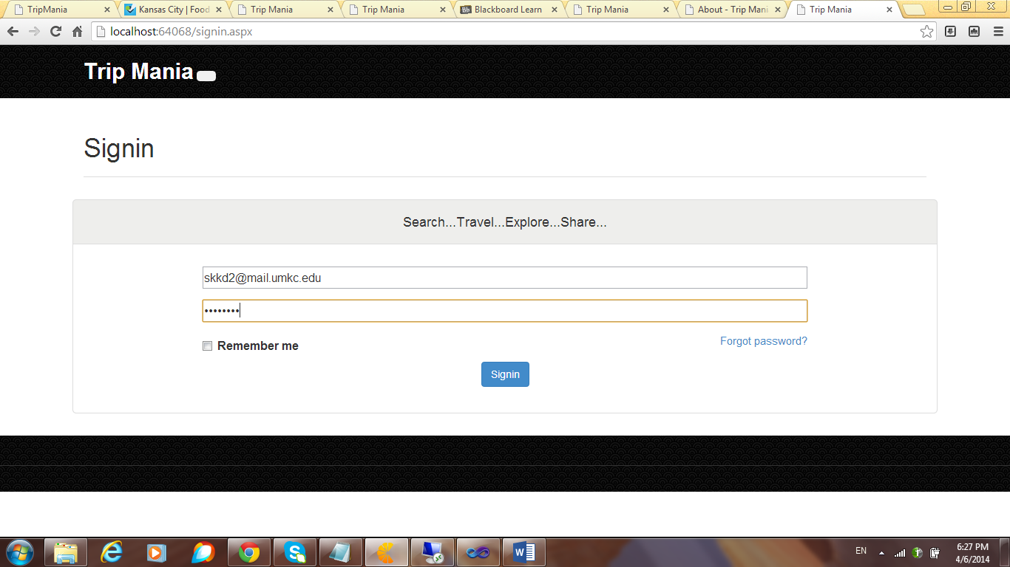

--When the user signs in to the application, the following welcome page appears. I have provided the logout button at the extreme left hand side. The user can view his recent visit history. The recent visit history contains the pictures of the places that have been previously visited. This makes the user feel good when he logs in to the application, it brings the memories back. The screen shots are as follows.

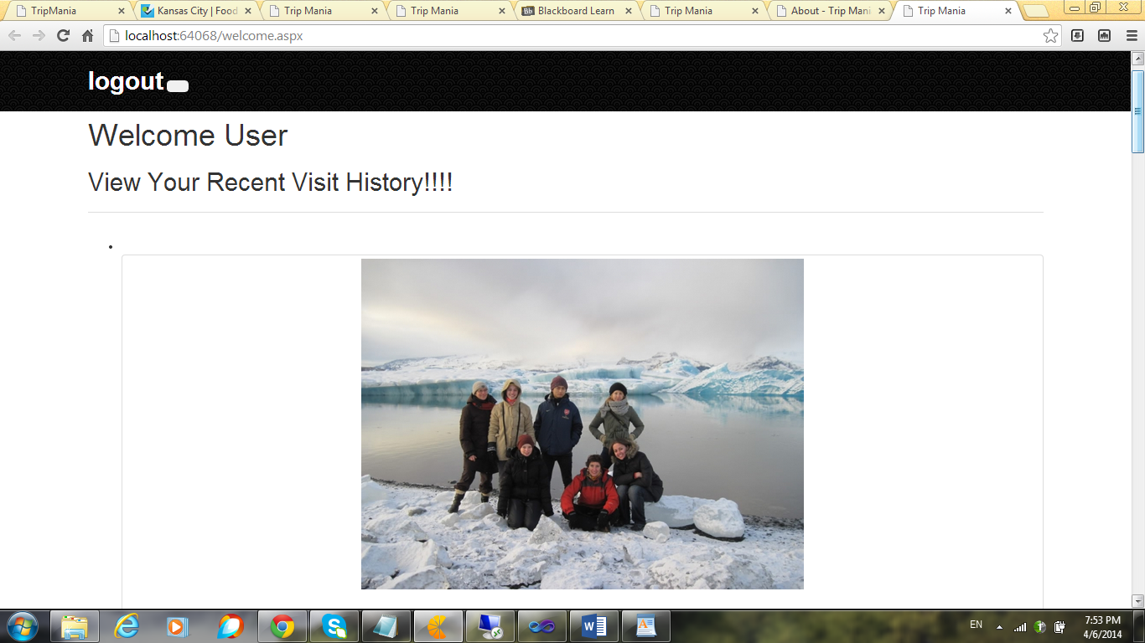

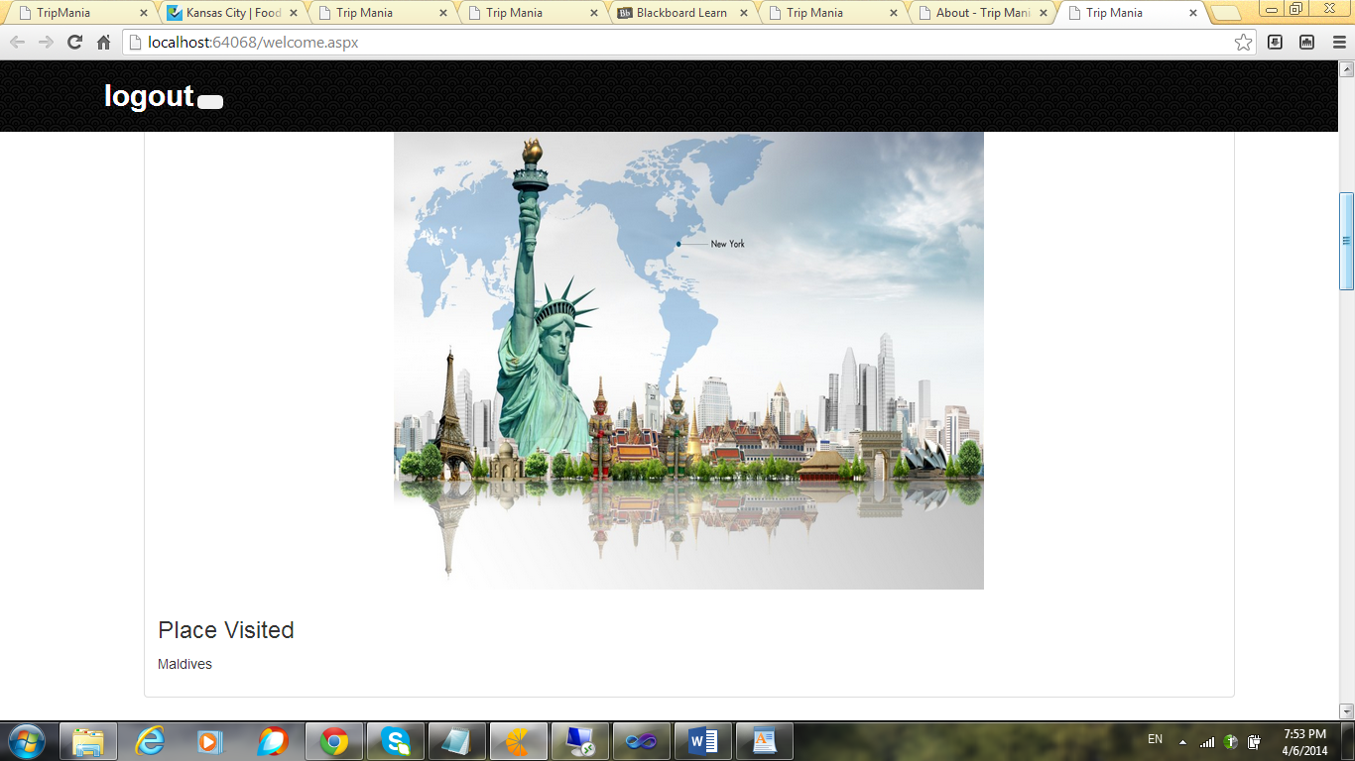

--The user can go refresh through the places he visited by scrolling down.

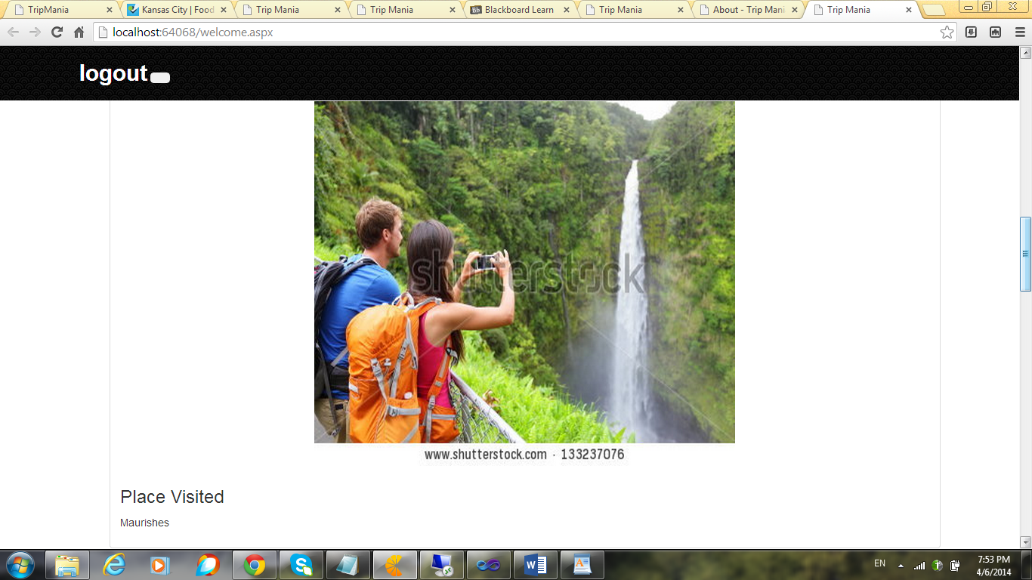

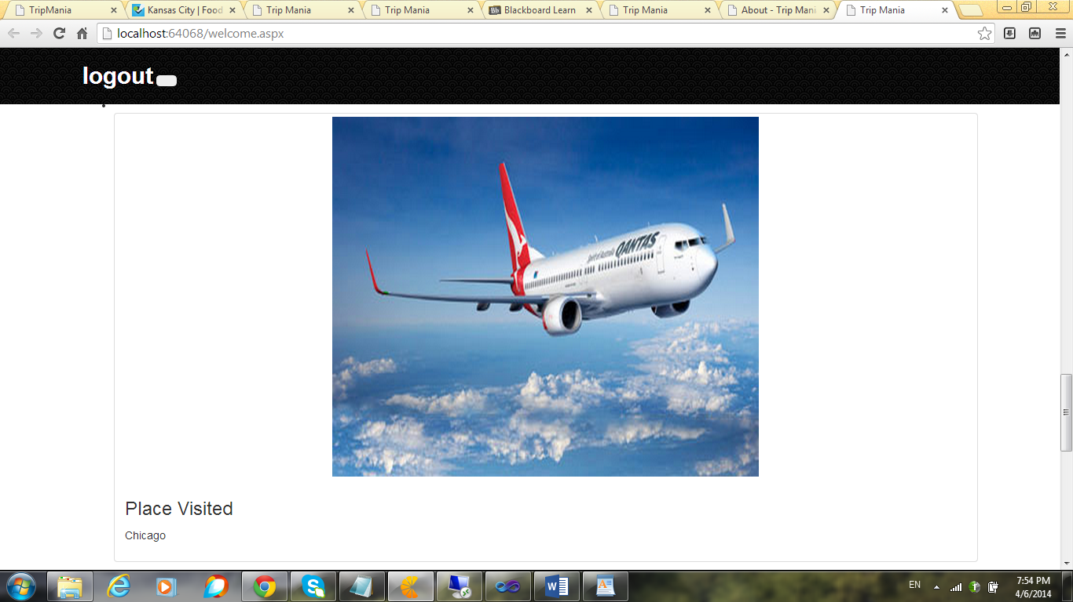

--At the bottom of the page, I have given two page navigations, one being the current location service and the other being the search service.

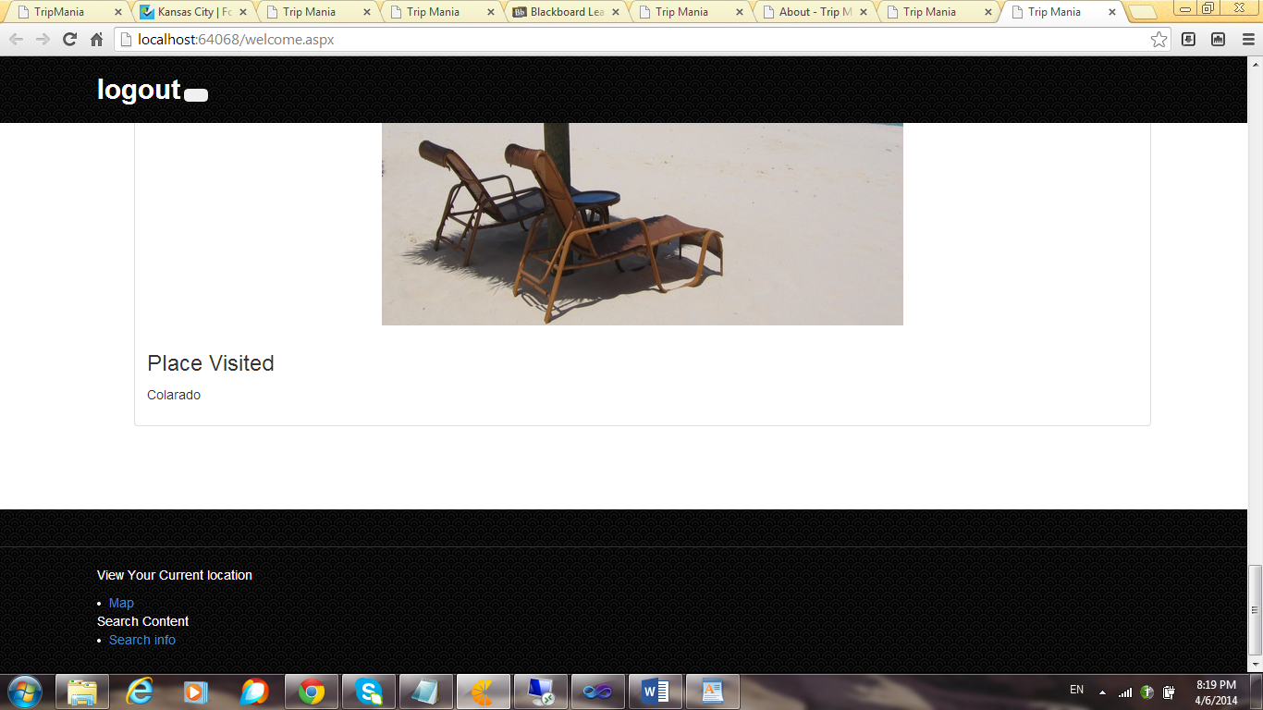

--When the map navigation is clicked, the current location of the user is shown so that he gets knowledge on the nearby places.

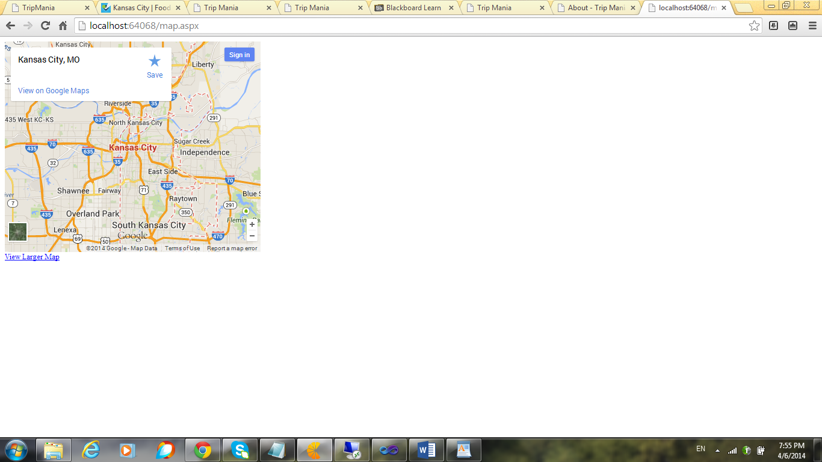

--When the search info link at the bottom of the page is clicked, the following page appears, the user can search the data he wants conveniently, the user can search any data he wants through this.

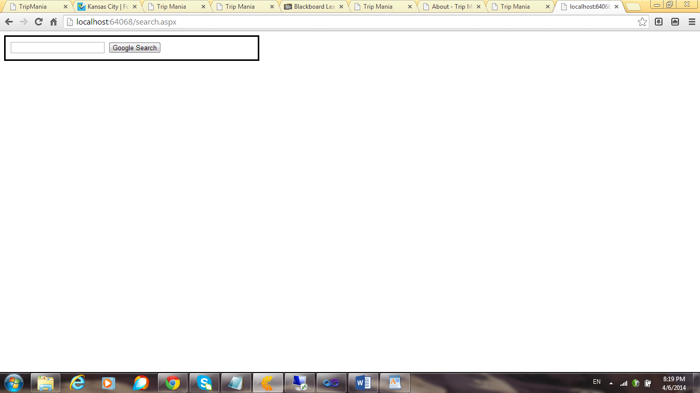

--I have entered “places to visit in New York” and hit the google search

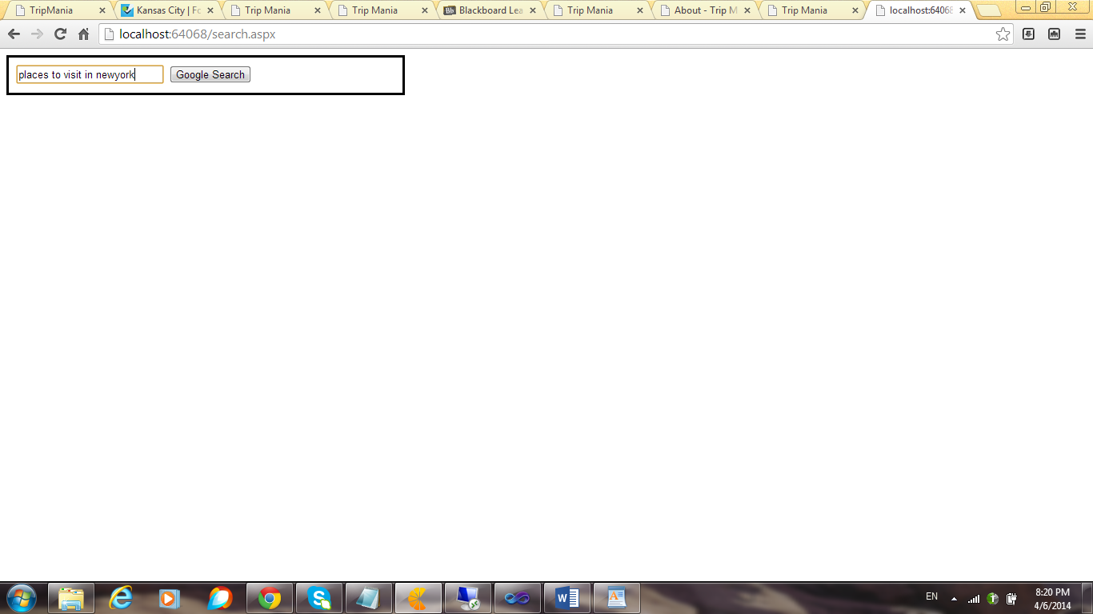

--When the button is clicked, the following information appears through the search engine and it shows huge amount of useful data.

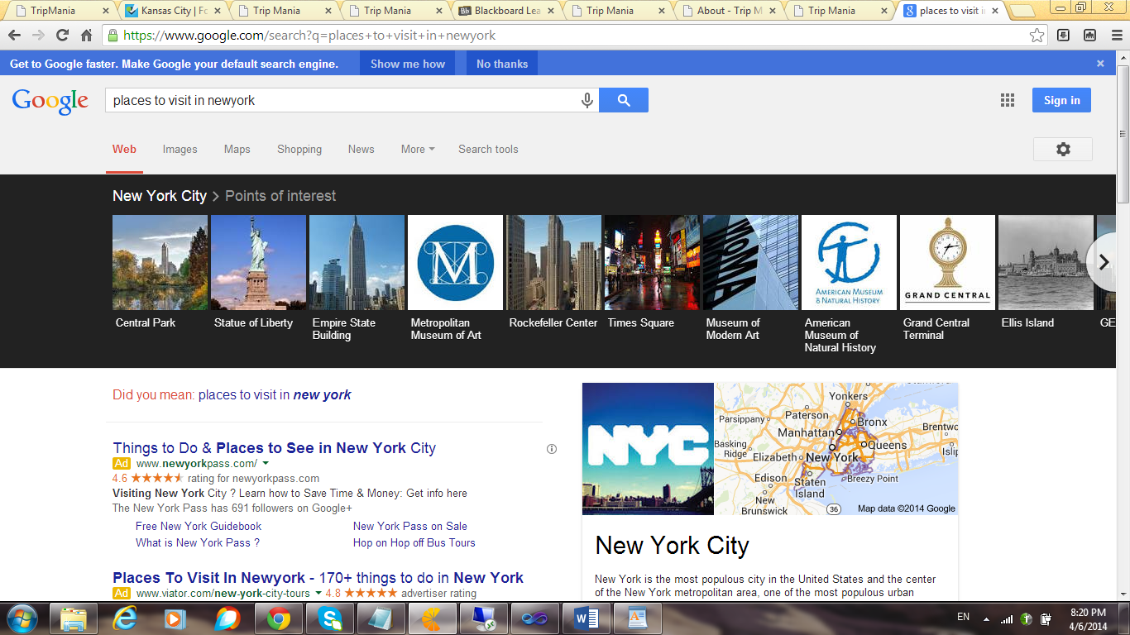

--When the user enters “directions from KC to Chicago” in the text box and hits the search button,

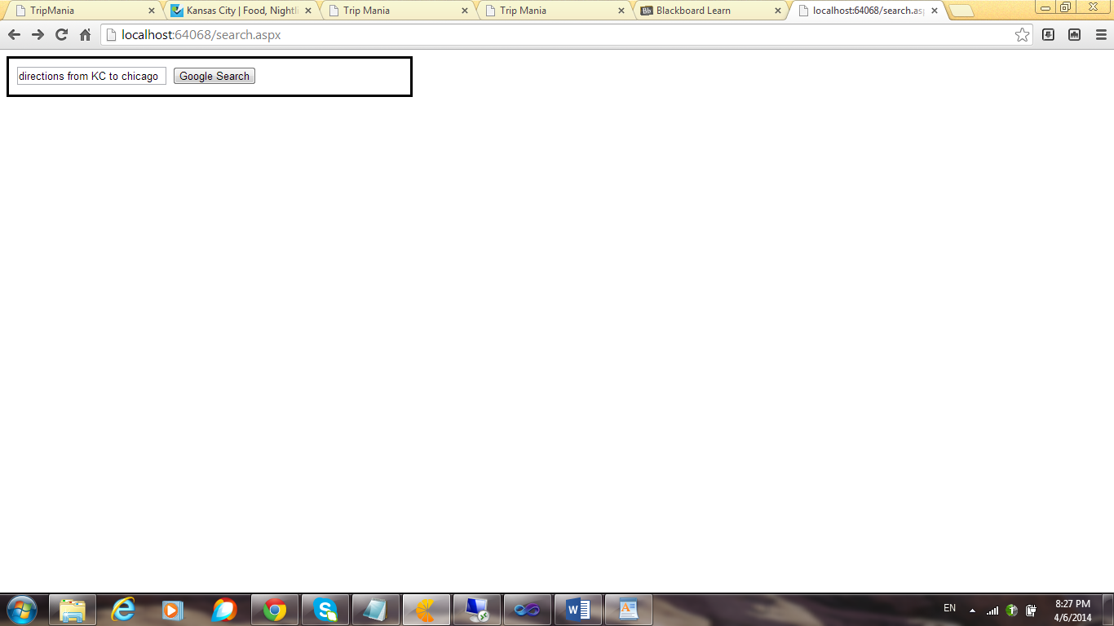

--The following page appears showing the directions from KC to Chicago.

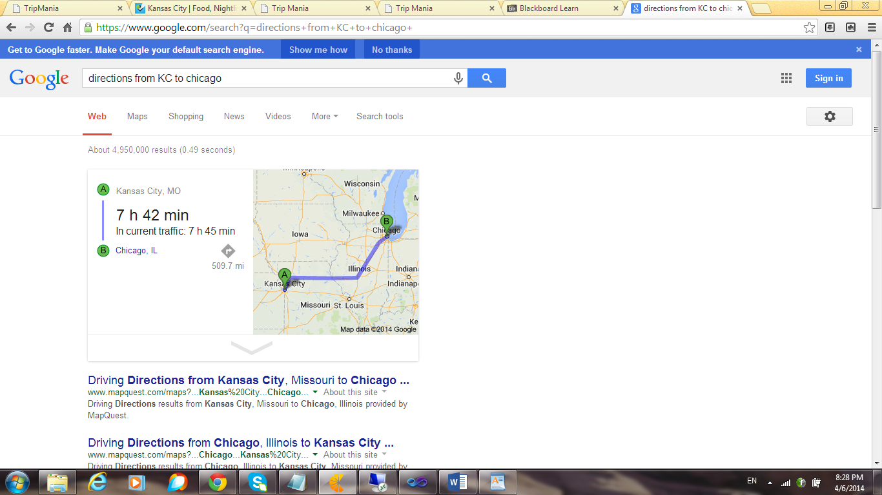

--He can get directions on the map as shown below.

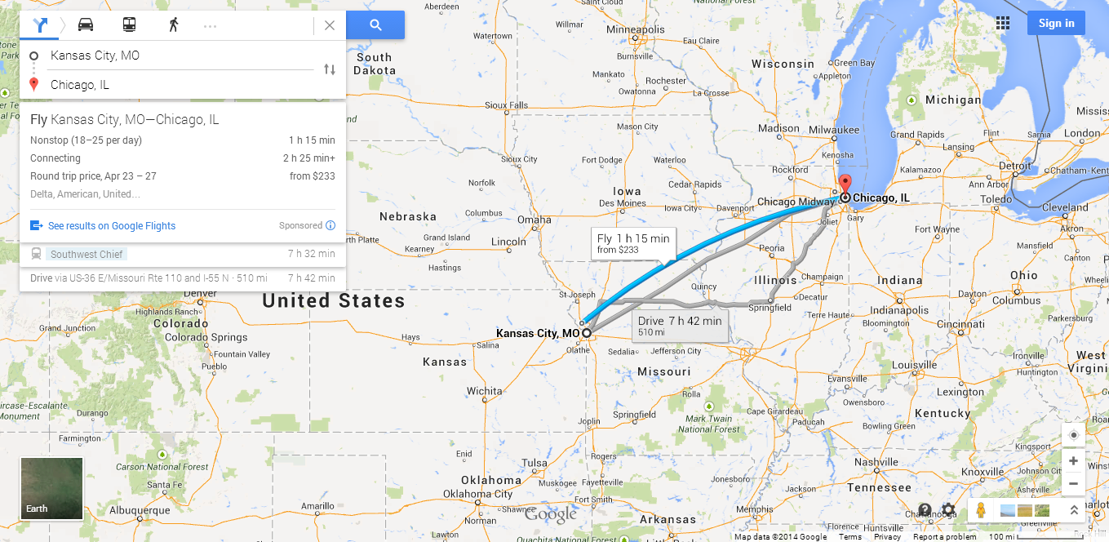

--When the logout page at the extreme left is clicked,

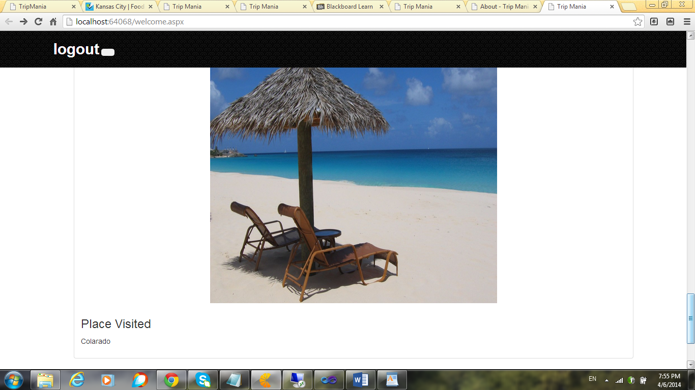

--The following page appears after the logout process.

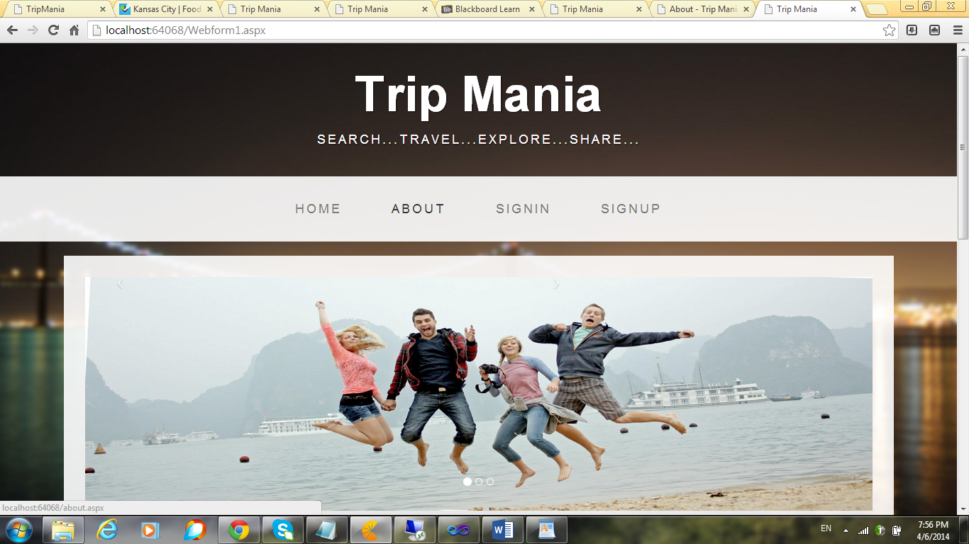

Limitations:

I am still working on this application, I still need to add features for adding/sharing photos.

I am planning to implement this app in a more user friendly way.

Reference

<https://www.youtube.com/user/joinvimals/videos>

<http://www.w3schools.com/aspnet/aspnet_refwebcontrols.asp>

<http://startbootstrap.com/business-casual>

<https://www.google.co.in/>

<http://www.youtube.com/results?search_query=programming+knowledge+tutorials+asp.net>

http://getbootstrap.com/